ENVIRONMENTAL KUZNET CURVE

The Environmental Kuznets Curve (EKC) describes the relationship between economic growth and environmental degradation, typically showing an inverted U-shape.
At the early stages of economic growth, industrialization and increased production lead to higher pollution and resource use, causing environmental degradation. However, after reaching a certain income or GDP per capita level (called the turning point), societies begin to demand cleaner technologies, better regulations, and environmental protection. As a result, pollution levels start to decline even as the economy continues to grow.
Mathematically, the EKC is often represented as:
$$E=β_{0}+β_{1}Y+β_{2}Y^{2}+ϵ$$
where $E$is environmental degradation, $Y$is income (GDP per capita), and an inverted U-shape occurs when $β_{1}>0$and $β_{2}<0$.
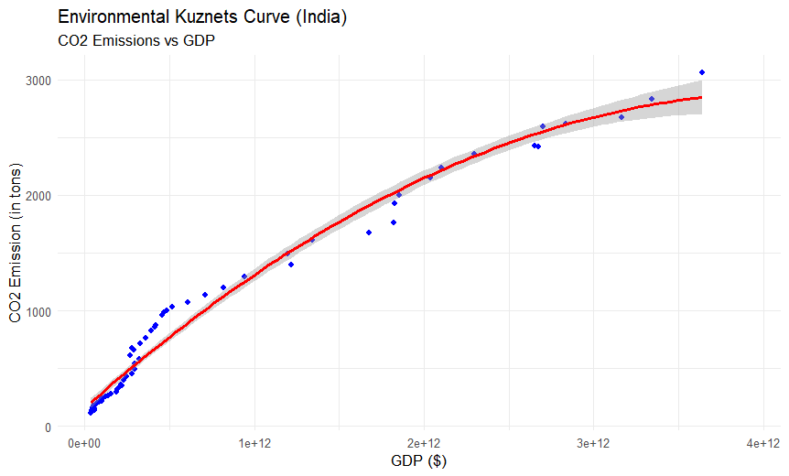

🔍 Interpretation:
- The red curve represents the fitted EKC model, and the blue points are actual data values.
- The upward trend indicates that as India’s GDP increases, CO₂ emissions also rise.
- The curve hasn’t clearly turned downward yet, meaning India is still likely in the rising part of the EKC — the phase of economic growth where industrialization continues to increase emissions.
- The turning point, where emissions start to decline with further growth, may occur at a higher GDP level in the future as cleaner technologies and environmental policies strengthen.
In short, the plot suggests economic growth in India currently increases CO₂ emissions, consistent with the early stage of the EKC.

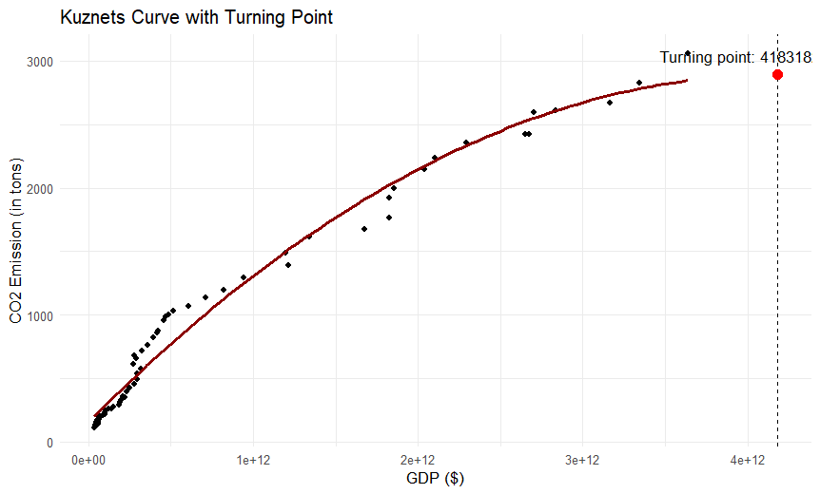

Interpretation:
- The red curve represents the estimated Environmental Kuznets Curve (EKC).
- The black dots are observed data points.
- The dashed vertical line and red point mark the turning point GDP = 4.18 × 10¹² ($).
- Up to this GDP level, CO₂ emissions increase with economic growth due to industrialization and energy use.
- Beyond this turning point, the model predicts that emissions would begin to decline as the economy becomes cleaner and more efficient through better technology and policies.
In summary:
India’s EKC currently shows a rising trend, with the curve starting to flatten near the turning point, suggesting that environmental improvements may emerge as economic growth continues and sustainability measures strengthen.
